

Department of Computer Science & Engineering

Microprocessor & Computer Architecture - UE20CS252

MPCA-Laboratory/Assignment/Hands-on/Project

NAME: HITHESH PATEL

SRN: PES1UG20CS166

SECTION: C

1. Write a program in ARM7TDMI-ISA to find the sum of all the digits in a 32bit number.

Code:

;sum of the digits

.DATA

A: .WORD 6666

SUM: .WORD

.TEXT

LDR R5,=A

LDR R0,[R5]

MOV R2,#0 ;here r2 will have final sum value

MOV R3,#0

MOV R4,#0

LOOP:

MOV R4,#0

DI:

CMP RO,#10

BMI FINISH

SUB R0,R0,#10

ADD R4,R4,#1

B DI

FINISH:

MOV R3,R0

ADD R2,R2,R3

MOV R0,R4

CMP R0,#0

BNE LOOP

B EXIT

EXIT:

LDR R9,=SUM

STR R2,[R9]

SWI 0X011

Output Screenshot:

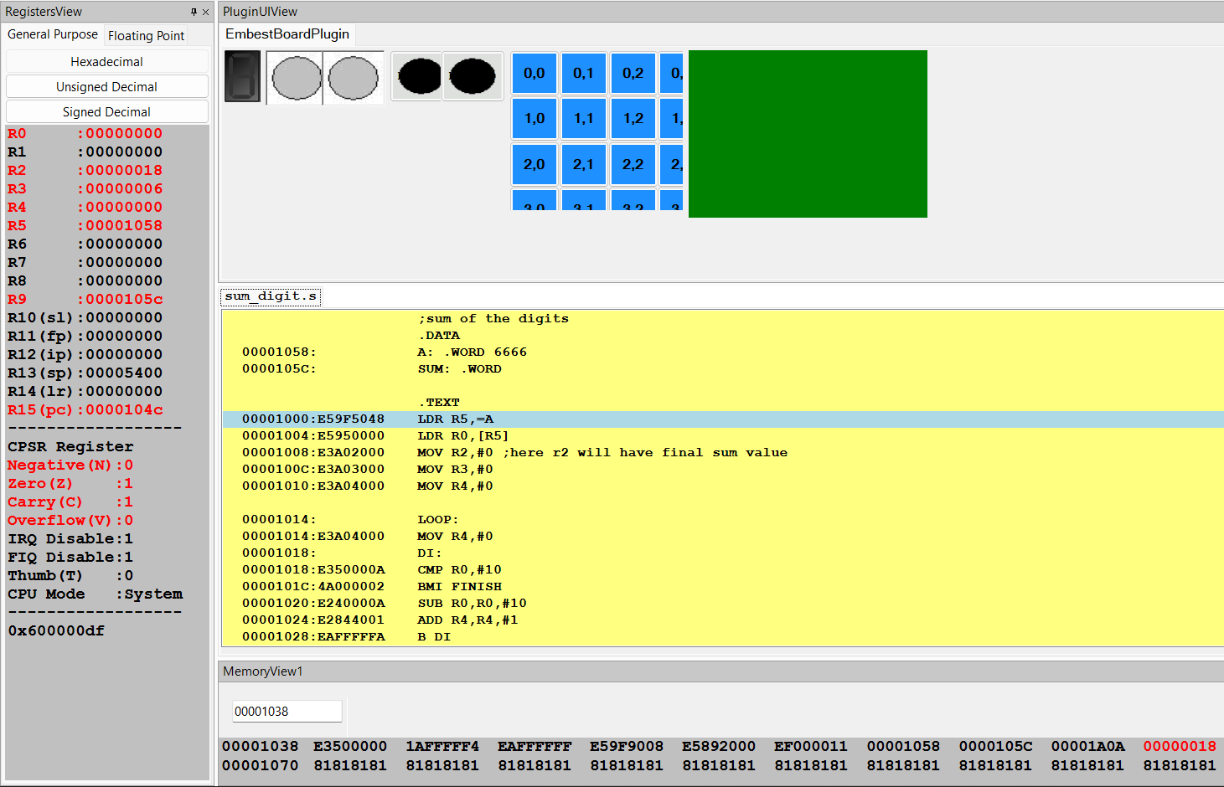

1. Write a program in ARM7TDMI-ISA to find the number of occurrences of a given character in a string. Example: Given string : My name is Bond. Character : ‘n’. Expected Output : Display 2 in a register.

Code:

;counting the number of occurens of a letter

.DATA

MYSTR: .ASCIZ "FooBarBaz"

QUERY: .ASCIZ "o"

.TEXT

LDR R0,=MYSTR

LDR R1,=QUERY

LDRB R1,[R1]

MOV R2,#0

LOOP:

LDRB R3,[R0]

CMP R3,#0

BEQ END

CMP R3,R1

BEQ TERMINATE

ADD R0,R0,#1

B LOOP

TERMINATE:

ADD R2,R2,#1

ADD R0,R0,#1

B LOOP

END:

SWI 0X011

Output Screenshot:

